Python Functions –

A collection of related assertions that carry out a mathematical, analytical or evaluate operation is known as a function.

Advantages –

We can stop a program from repeatedly using the same blocm by including functions

Syntax –

Def function_name(paramters):

Code block

User defined function -

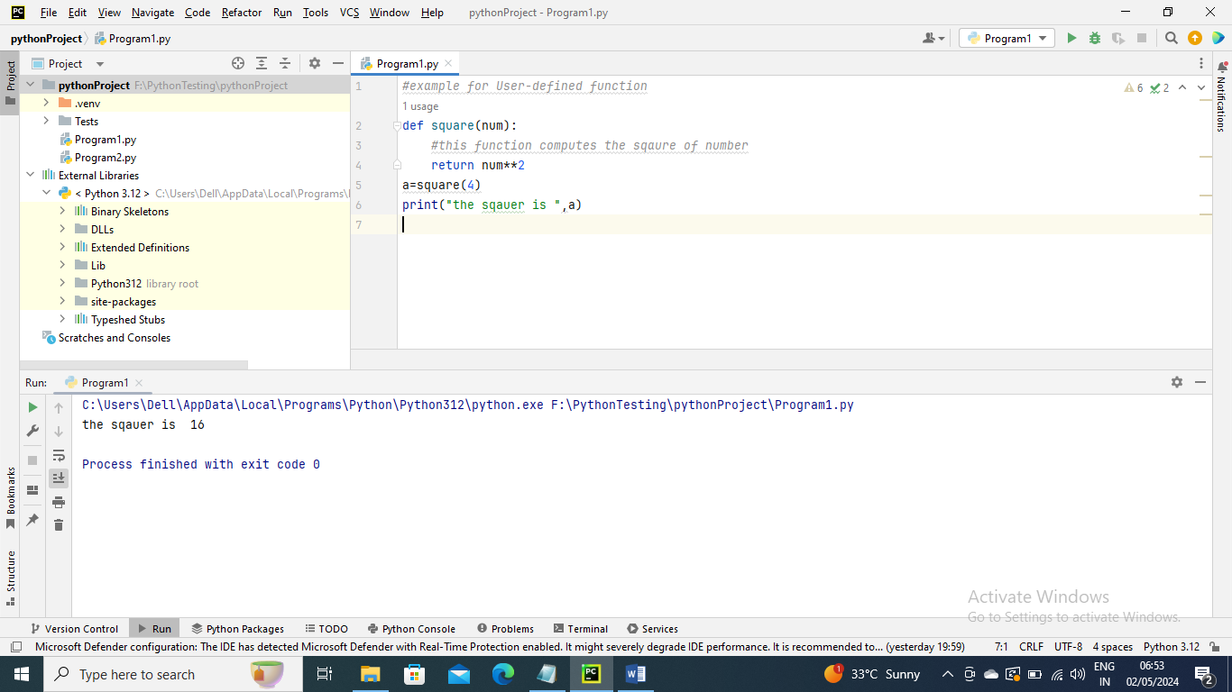

Calling a Function

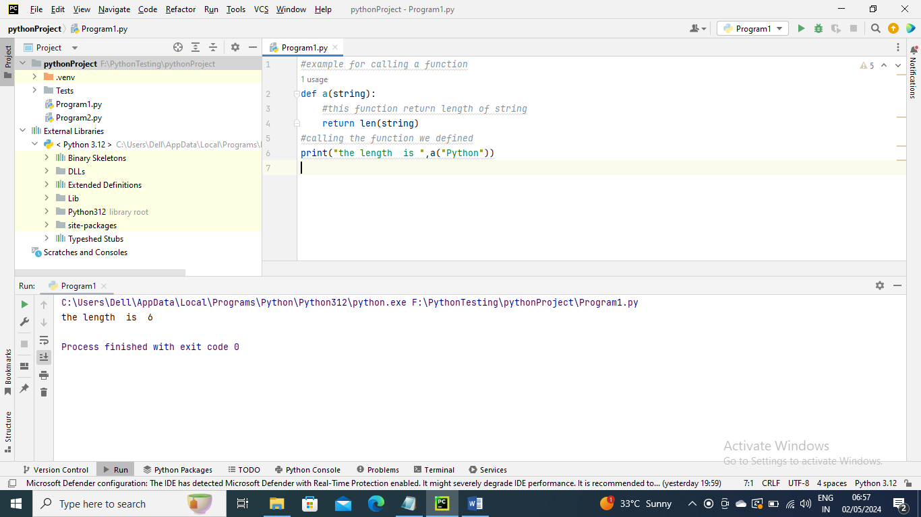

Pass by Reference vs Pass by value

In Python, all parameters are passed by reference. It shows that if we modify the worth of contention within a capability, the calling capability will similarly mirror the change

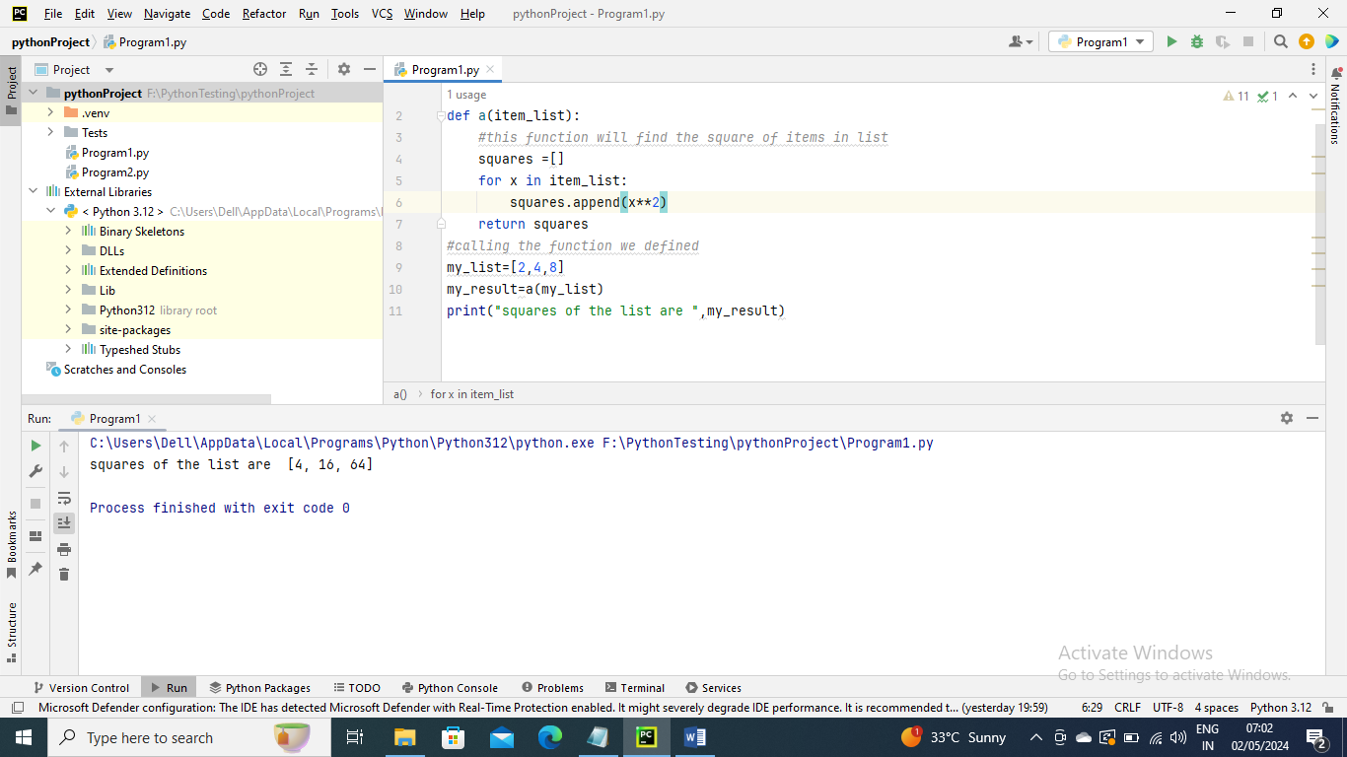

Function Arguments

1. Default Arguments
2. Keyword Arguments
3. Required Arguments
4. Variable-length Arguments

Default Argument –

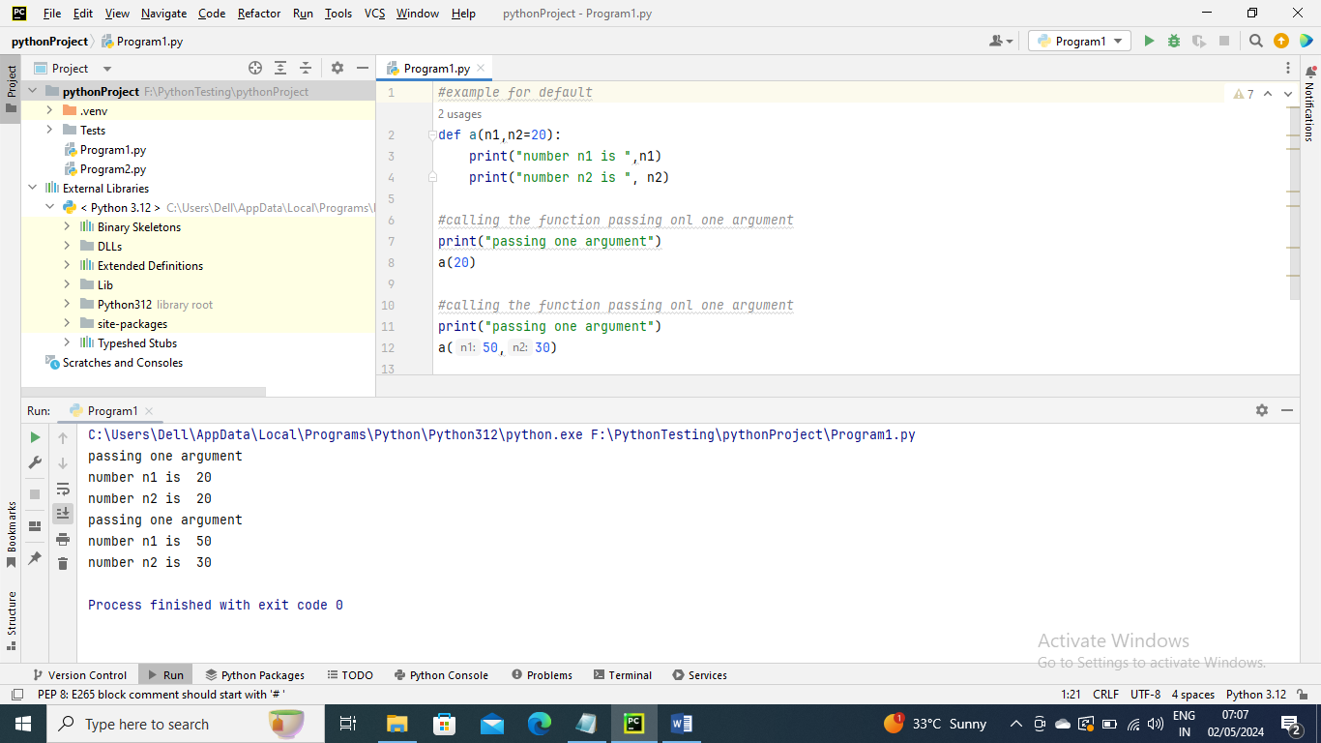

Keyword Arguments –

In keyword the system gives n1 and n2 in a() function automatically

In above screen shot you can see a(n1 :50 and n:30) here n1 and n2 is directly opulated by Python

Required Arguments –

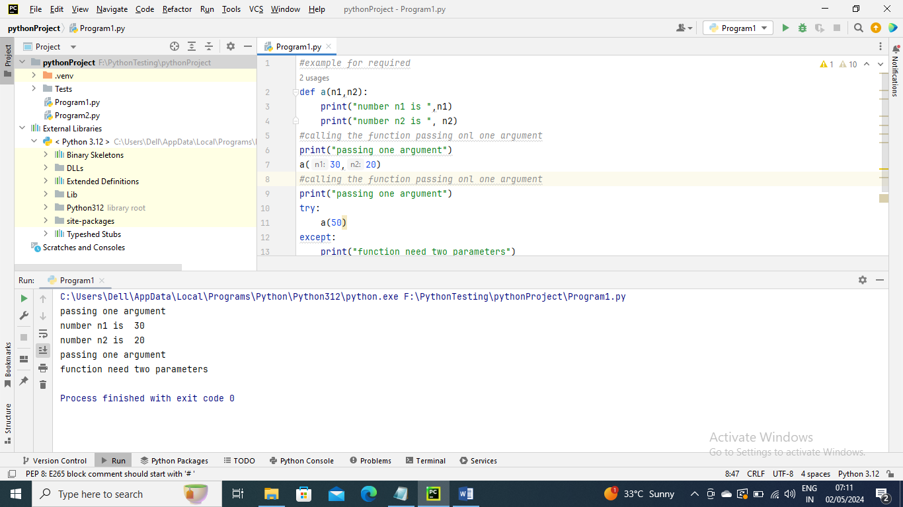

Variable-length Argument

We can involve unique characters in Python capabilities to pass many contentions. However we need a capability. This can be accomplished with one of two types of characters

“args” and “kwargs” refer to arguments not based on keyqords

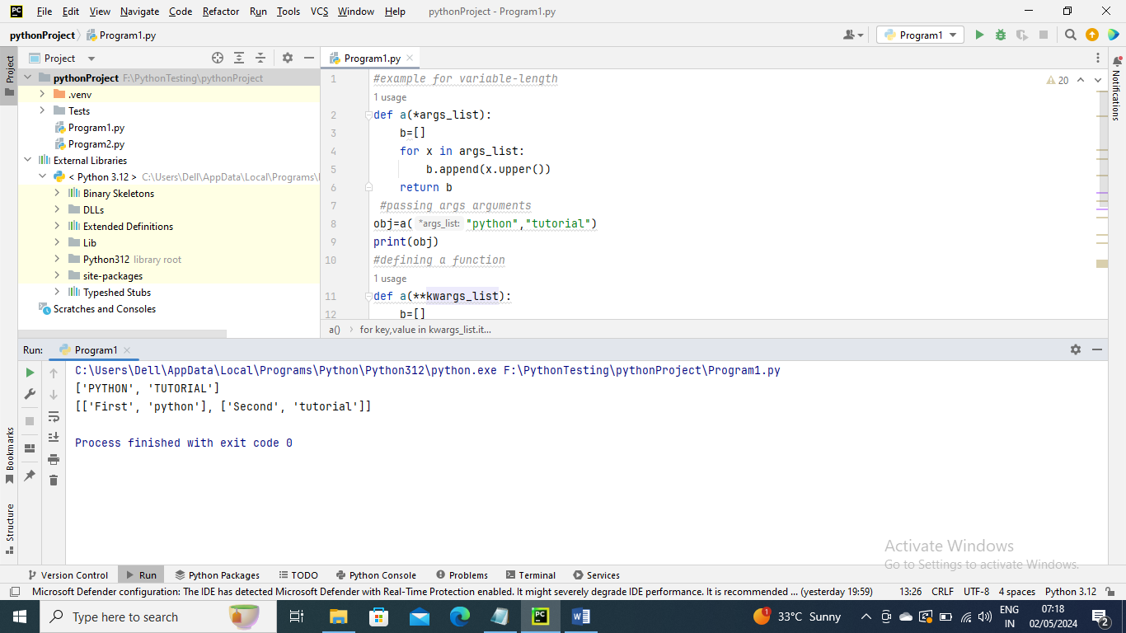

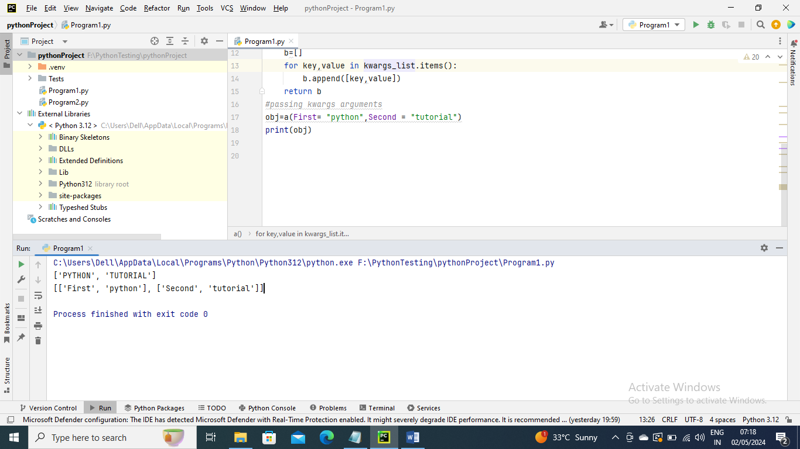

Anonymous Functions –

Since we do not use the def keyword to declare these kinds of Pyhton Functions, thye are unknown.

The lambda keyword can be define anonymous , short, single-output functions

Syntax –

Lambda [argument1,argument2….]:expression

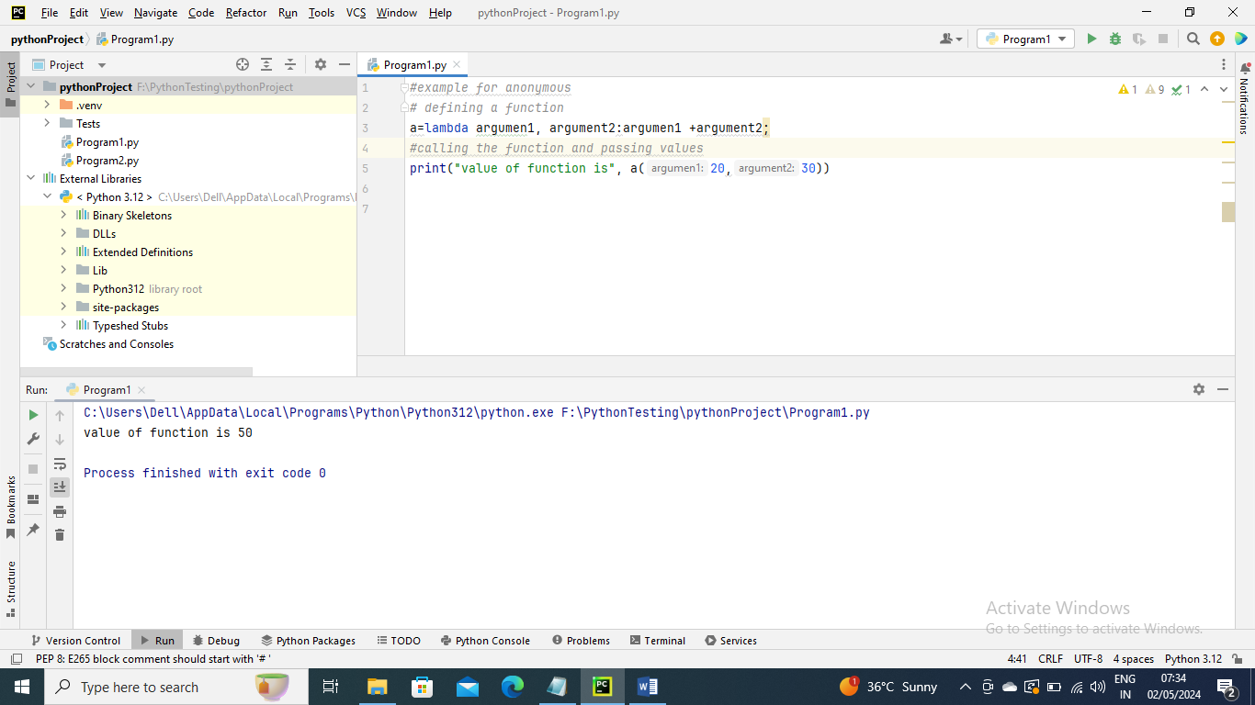

Scope and lifetime of variables

The scope of variable if defined inside a function will be till that function only

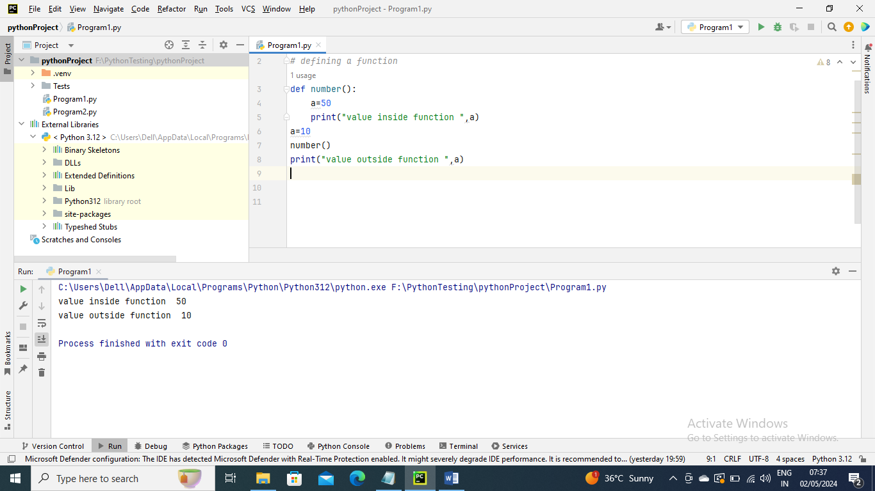

Python Capability inside another capability (Nested Functions)

